

CSF3133  
REKA BENTUK ANTARA MUKA BERASASKAN WEB

Name: CHONG YU

Matric Number: S76136

Lecturer: Assoc. Prof. Ts. Dr. Wan Nural Jawahir Wan Yussof

Activity 2.3

Question 1

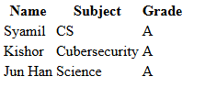

Question 2

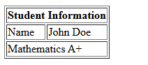

Activity 2.4.1

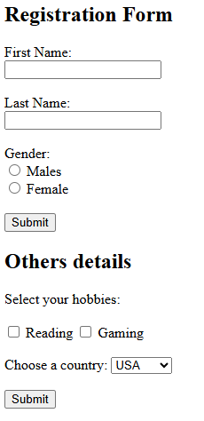

Activity 2.4.2



Activity 2.5

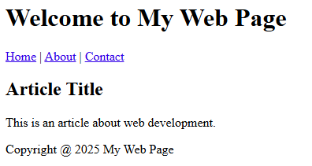

Lab exercise:

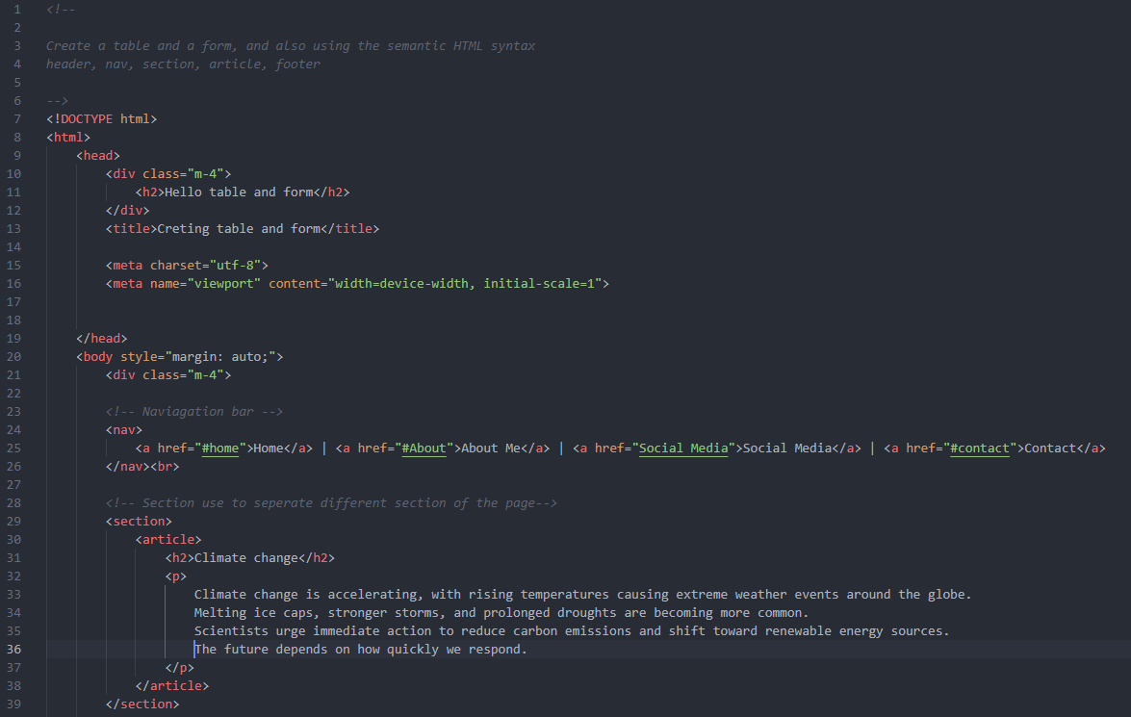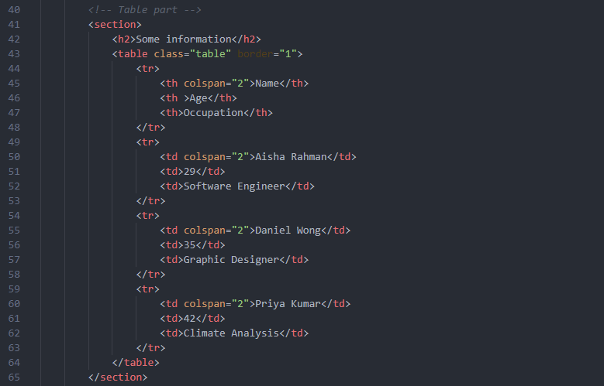

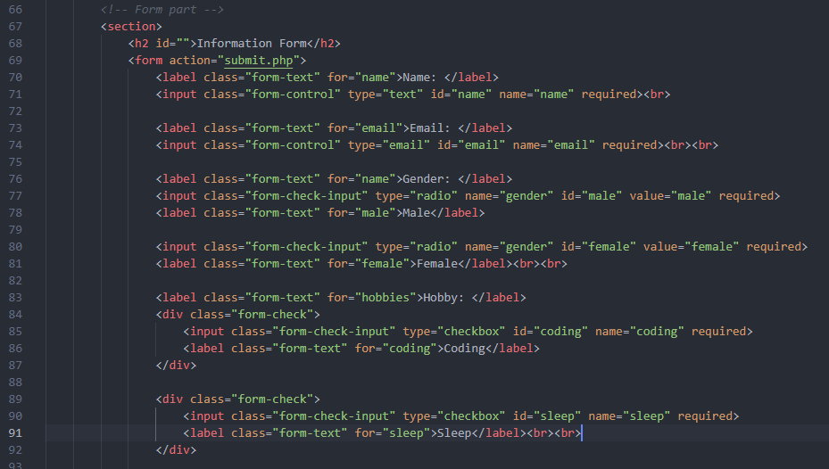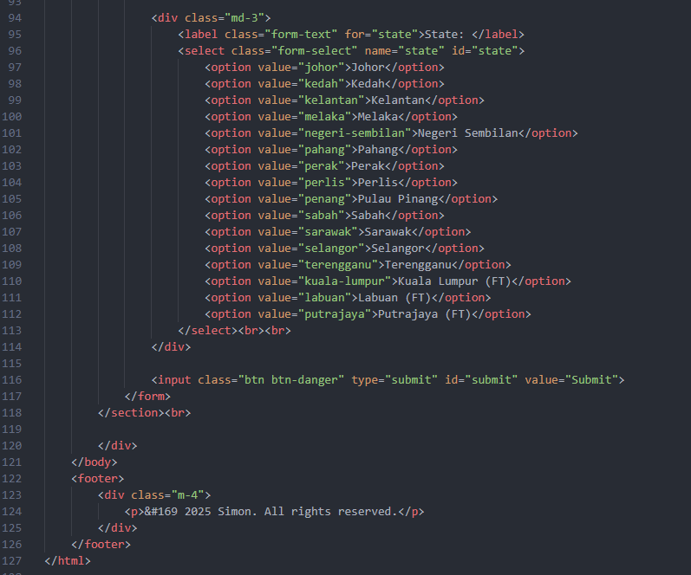

Output:

